H.T No
Regulations:
A19

Sreenidhi Institute of Science and Technology
(An Autonomous Institution)
Code No: 7P256 Date: 27-Oct-2021 (FN)

M.Tech I-Year II-Semester External Examination, Oct/Nov - 2021 (Regular & Supplementary)
MACHINE LEARNING (CSE and CS)

Time: 3 Hours Max.Marks:70

Note: a) No additional answer sheets will be provided.
b) All sub-parts of a question must be answered at one place only, otherwise it will not be valued.
c) Missing data can be assumed suitably.

ANSWER ANY 5 OUT OF 8 QUESTIONS. EACH QUESTION CARRIES 14 MARKS.

Bloom's Cognitive Levels of Learning (BCLL)

Remember | L1 | Apply | L3 | Evaluate | L5
Understand | L2 | Analyze | L4 | Create | L6

 |  |  | BCLL | CO(s) | Marks
1. | a) | Explain candidate Elimination algorithm. | L3 | CO1 | [7M]
 | b) | Discus how concept learning a searching problem . | L3 | CO1 | [7M]
2. | a) | Write multilayer perceptron Algorithm. | L2 | CO2 | [7M]
 | b) | Summarized Support vector machine. | L4 | CO2 | [7M]
3. | a) | Find root node of decision tree using ID3 Algorithm using following data  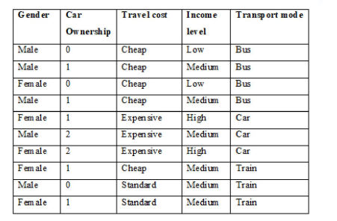 | L3 | CO3 | [7M]
 | b) | Demonstrate K-means algorithm. | L2 | CO3 | [7M]
4. | a) | Explain about linear discriminant analysis(LDA). | L4 | CO4 | [7M]
 | b) | Illustrate genetics algorithm operations. | L3 | CO4 | [7M]
5. | a) | Describe hidden Markov model. | L3 | CO5 | [7M]
 | b) | Discus about graphical models. | L3 | CO5 | [7M]
6. | a) | Discuss advantages of KBANN. | L3 | CO6 | [7M]
 | b) | Explain about learning with perfect domain theory. | L3 | CO6 | [7M]
7. |  | Write shot note on:
 | a) | Version Space. | L1 | CO1 | [5M]
 | b) | Back Propagation error. | L1 | CO2 | [5M]
 | c) | Unsupervised Learning. | L1 | CO3 | [4M]
8. | a) | Discuss about factor analysis. | L3 | CO4 | [5M]
 | b) | Illustrate Bayesian Networks. | L3 | CO5 | [5M]
 | c) | Write in brief about explanation based learning. | L1 | CO6 | [4M]

-- 00 -- 00 –

